Name: Chimzim Ogbondah
Section: 9
University ID: 273362113

Lab 4 Report

Summary (10pts):
During this lab I got to learn about signals and signal handling as well as inter process communication. In the first part of the lab I learned on how signals are handled using the signal() function. There are two arguments to this function the first which is the signal and the second being the handler. In Experiment 1, 2 and 3 I got to learn more on the signals that deal with Killing, dividing by zero and ignoring. In experiment 4 I learned about the alarm signal and how it waits for the given amount of time before sending the signal. Then in experiment 5 I saw how signals can be used with fork() which the flowed into experiment 6 when we piped to see how reading and writing works. During experiment 7 I got to learn about inter process communication which came through the sharing of memory. The two files shm_client/server shared memory with each other through the system call of shmget(). I also saw how this shared memory could be deleted and specifically how to separate processes could share the same memory space using shmget(). In experiment 8 after reading the man pages I go to learn a little bit more on message queues.

Lab Questions (80 pts):
3.1 - Introduction to Signals
6pts After reading through the man page on signals and studying the code, what
happens in this program when you type CTRL-C? Why?
In the first statement signal(SIGINT, my_routine); the SIGINT corresponds with the CTRL-C and its saying that when it receives the signal it should stop the process to do something else. In this case it runs my_routine() which prints out our statement.
3pts Remove the signal(...) statement in main. Recompile and rerun the program. Type CTRL-C. Why did the program terminate? Hint: ﬁnd out how a program usually reacts to receiving what CTRL-C sends (man 7 signal).
Default action is to terminate the process

3pts Replace the signal( ) statement with signal(SIGINT, SIG_IGN). Run the program and press CTRL-C. Look up SIG_IGN in the man pages. What’s happening now? (HINT: Look up SIG_IGN in man signal)
It continues running the infinite loop because SIG_IGN is telling it to ignore the signal.

3pts The signal sent when CTRL-\ is pressed is SIGQUIT. Replace the signal() statement with signal(SIGQUIT, my_routine) and run the program. Press CTRL-\. Why can't you kill the process with CTRL-\ now?
Because we are now handling the CTRL-\ to run my_routine instead of quitting the program

3.2 – Signal Handlers
5pts What are the integer values of the two signals? What causes each signal to be sent?
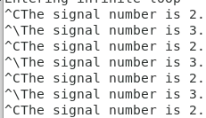

3.3 – Signals for Exceptions
10pts Include your source code
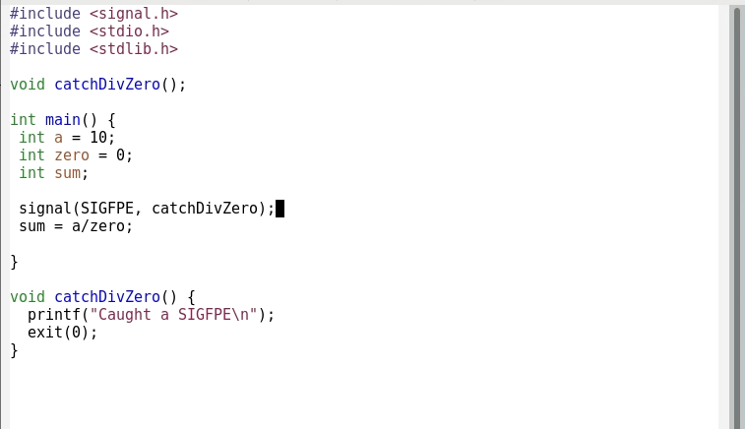

5pts Which of the following statements should come ﬁrst to trigger your signal handler? The signal() statement, or the division-by-zero statements. Explain why.
The signal handler should come first otherwise it will through a Null pointer exception. It would make sense that it needs to come first so that way we tell the program what to do when it encounters the error prior to encountering the error

3.4 – Signals using alarm()
4pts What are the input parameters to this program, and how do they affect the program?
The input parameters come from the command line when starting the program. They affect the program because if more than 3 things aren’t enter when starting (including ./[program]) then it will cause the program to quit. It affects the program because it atoi() uses one of the parameters and turns the string into an integer value. Based on this integer value the program will quit because of the alarm() call and the SIGALARM handling which will call our function which also calls exit()

6pts What does the statement alarm(time) do? Mention how signals are involved.
The variable time is set by calling atoi() which turns the second parameter from the command line into an integer value. The statement alarm(time) arranges for a signal: SIGALARM to be sent after “time” in seconds has reached zero.

3.5 – Signals and fork
2pts How many processes are running?
2 additional processes are running due to the call to fork()

2pts Identify which process prints out which message.
The child process prints out : return value from fork = 0
The parent process prints out: return value from fork = 9492

2pts How many processes received signals?
2

3.6 - Pipes
2pts How many processes are running? Which is which (refer to the if/else block)?
2

6pts Trace the steps the message takes before printing to the screen, from the array msg to the array inbuff, and identify which process is doing each step.
The parent process is writing to the array while the child process reads from the array and then prints

2pts Why is there a sleep statement? What would be a better statement to use instead of sleep for this small example? Hint: you might have to switch the role of parent and child…
The sleep statement allows the parent to write before the child reads which allows the child to actually read some data. A better statement would be to use a wait(&status) which would make the parent wait until the child is done running but the roles would need to be switched. (child writes, parent reads)

3.7 – Shared Memory
2pts How do the separate processes locate the same memory space?
They locate it by the key ID which comes from creating the key “Key = 5678” and then calling shmget()

3pts There is a major flaw in these programs. What is it? Hint: think about race conditions.
Since both programs are using the same memory space, they could access it at the same time which would cause a race condition which could lead to memory leaks.

3pts Now run the client without the server. What do you observe? Why?
Instead of printing abcdefghijklmnopqrstuvwxyz it prints “*bcdefghijklmnopqrstuvwxyz” because at the end of the server it sets the first character in the list to be * so when it runs with out the server it won’t get changed back.

3pts Recompile the server. First run the server and client together. Then run the client without the server. What do you observe? What did the two added lines do? (HINT: look at the man pages of shmdt and shmctl; look for the explanation of IPC_RMID in the shmctl man pages)
When the server and client are running at the same time the output is the same. When only the client is running it gives and output of no file or directory because IPC_RMID destroys the segment of shared memory which happens through the shmctrl() statement which perfomes a control operation with specified commands. (IPC_RMID) so after the client and server ran together it destroyed the shared memory. Hence why when running the server again it can’t access it because it doesn’t exist.

3.8 – Message Queues and Semaphores
2pts Read the man pages of msgsnd. Message queues allow for programs to synchronize their operations as well as transfer data. How much data can be sent in a single message using this mechanism?
0 to system defined max

2pts Read the man pages of msgrcv. What will happen to a process that tries to read from a message queue that has no messages of the requested type? Hint: there are multiple different cases.
It sets the errno to ENOMSG which states that it is nit of the desired type

2pts Both message queues and shared memory create semi-permanent structures that are owned by the operating system (not owned by an individual process). Although not permanent like a file, they can remain on the system after a process exits. Describe how and when these structures can be destroyed.
The structures can be destroyed by using the system call shmclt() and then giving it a parameter of IPC_RMID which destroys the shared memory segment

2pts Are the semaphores described by the above man pages counting semaphores (i.e. general purpose semaphores), or binary semaphores? Describe in brief how to acquire and initialize them.
Counting semaphores because it requires a key value to access the shared memory and this key value needs to be a non negative integer. For example in shm_client/server the key value was set to 5678

